**Use cases:**

* Process payment via external service.
* Process shipping via external service.
* Purchase a shopping cart.
* Browsing shop’s purchase history.
* Browsing customer’s purchase history.

**Order Module:**

**Use case: Process shipping via external service.**

1. **Actors**: User, External supply service
2. **Preconditions**: -
3. **Parameters**: -
4. **Actions**:
5. The user enters the details required for shipping (name, id, phone number, address).
6. System approaches an external supply service.
7. The external shipping service confirms the shipping.
8. **Alternatives**:
9. The shipping is not available.

a.1 The user is asked to alter the shipping details.

a.2 The user enters new details.

a.3 Back to step 1

**Acceptance Tests:**

|  |  |
| --- | --- |
| Positive | The user enters valid details for shipping and the shipping service can ship to the given address.  **Outcome**: The shipping is confirmed. |
| Negative | The user enters an invalid phone number.  **Outcome**: The shipping is not confirmed, and the user can modify the details. |

**Use case: Process payment via external service.**

1. **Actors**: User, External Payment service
2. **Preconditions**: A shipping is confirmed
3. **Parameters**: total amount to be paid
4. **Actions**:
5. The system presents the user with the available billing services.
6. The user chooses a service.
7. The user enters the details required for billing (name, id, credit card num, cvc, expire date).
8. System approaches an external billing service.
9. The External billing service confirms the payment.
10. **Alternatives**:
    1. The billing fails.

a.1 The user is asked to alter the billing details.

a.2 The user enters new details.

a.3 Back to step 3

**Acceptance Tests:**

|  |  |
| --- | --- |
| Positive | The user enters valid details for billing.  **Outcome**: The payment is confirmed. |
| Negative | The user enters an invalid credit card number.  **Outcome**: The payment is not confirmed, and the user can modify the details. |

**Use case: Purchase a shopping cart.**

1. **Actor**: User, Supply system, Billing System
2. **Preconditions**:
3. The user has at least one item in his shopping cart
4. The shop’s purchase and discount policies are adhered to.
5. **Parameters**: Shopping cart
6. **Actions**:
7. Use case: process shipping via external service.
8. Use case: process payment via external service.
9. The system notifies the shop owners that items were purchased from their shop.

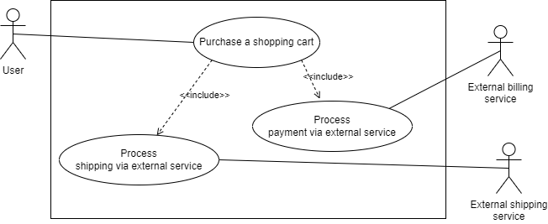

**Use case: Browse shop’s purchase history.**

1. Actors: Seller/admin
2. **Preconditions**:
3. The seller has browsing permissions over the shop’s purchase history.
4. A shop with the given id exists.
5. **Parameters**: shop id
6. **Actions**:
7. The system presents the shop’s purchase history to the seller/admin.

**Use case: Browse customer’s purchase history.**

1. **Actors**: Admin
2. **Preconditions:** -
3. **Parameters:** customer id
4. **Actions:**
5. The system presents the shop’s purchase history to the admin.

**Use case: Browse personal purchase history.**

1. **Actors:** Customer
2. **Preconditions:** -
3. **Parameters**: Customer’s id
4. **Actions:**
5. The system presents the customer with his purchase history.

**Use case: Browse purchase history.**

1. **Actors**: Admin
2. **Preconditions**:
3. **Parameters**:
4. **Actions**:
5. The system presents 2 options: “Browse shop’s purchase history”, “Browse customer’s purchase history”, “Browse personal purchase history”.
6. Admin selects “Browse shop’s purchase history.”
   1. The system asks for shop id.
   2. Use case Browse shop’s purchase history.
7. Admin selects “Browse customer’s purchase history.”
   1. The system asks for customer id.
   2. Use case Browse customer’s purchase history.
8. Admin selects “Browse customer’s purchase history.”
   1. Use case Browse personal purchase history.

